Morphological Filtering output
Code:
import cv2
import numpy as np
image = cv2.imread("olo.jpg")
gray = cv2.cvtColor(image, cv2.COLOR_BGR2GRAY)
_, binary = cv2.threshold(gray, 127, 255, cv2.THRESH_BINARY)
kernel = cv2.getStructuringElement(cv2.MORPH_RECT, (5, 5)) # Change (5, 5) as needed
erosion = cv2.erode(binary, kernel, iterations=1)
dilation = cv2.dilate(binary, kernel, iterations=1)
opening = cv2.morphologyEx(binary, cv2.MORPH_OPEN, kernel)
closing = cv2.morphologyEx(binary, cv2.MORPH_CLOSE, kernel)
gradient = cv2.morphologyEx(binary, cv2.MORPH_GRADIENT, kernel)
# Display results
cv2.imshow("Original", image)
cv2.imshow("Binary", binary)
cv2.imshow("Erosion", erosion)
cv2.imshow("Dilation", dilation)
cv2.imshow("Opening", opening)
cv2.imshow("Closing", closing)
cv2.imshow("Gradient", gradient)
cv2.waitKey(0)
cv2.destroyAllWindows()

Code explation :
- Erosion
  - Effect: Shrinks white regions in a binary image.
  - Use: Removes small noise, separates connected objects.
  - Code: cv2.erode(binary, kernel, iterations=1)
- Dilation
  - Effect: Expands white regions in a binary image.
  - Use: Fills small holes, connects nearby objects.
  - Code: cv2.dilate(binary, kernel, iterations=1)
- Opening
  - Effect: Erosion followed by dilation.
  - Use: Removes small noise, preserves larger objects.
  - Code: cv2.morphologyEx(binary, cv2.MORPH_OPEN, kernel)
- Closing
  - Effect: Dilation followed by erosion.
  - Use: Fills small holes, smooths contours.
  - Code: cv2.morphologyEx(binary, cv2.MORPH_CLOSE, kernel)
- Morphological Gradient
  - Effect: Difference between dilation and erosion.
  - Use: Edge detection, highlighting boundaries.
  - Code: cv2.morphologyEx(binary, cv2.MORPH_GRADIENT, kernel)
Steps to Apply:
- Read Image: cv2.imread()
- Convert to Grayscale: cv2.cvtColor()
- Apply Thresholding: cv2.threshold()
- Define Kernel: cv2.getStructuringElement()
- Apply Operations: cv2.erode(), cv2.dilate(), cv2.morphologyEx()
- Display Results: cv2.imshow()
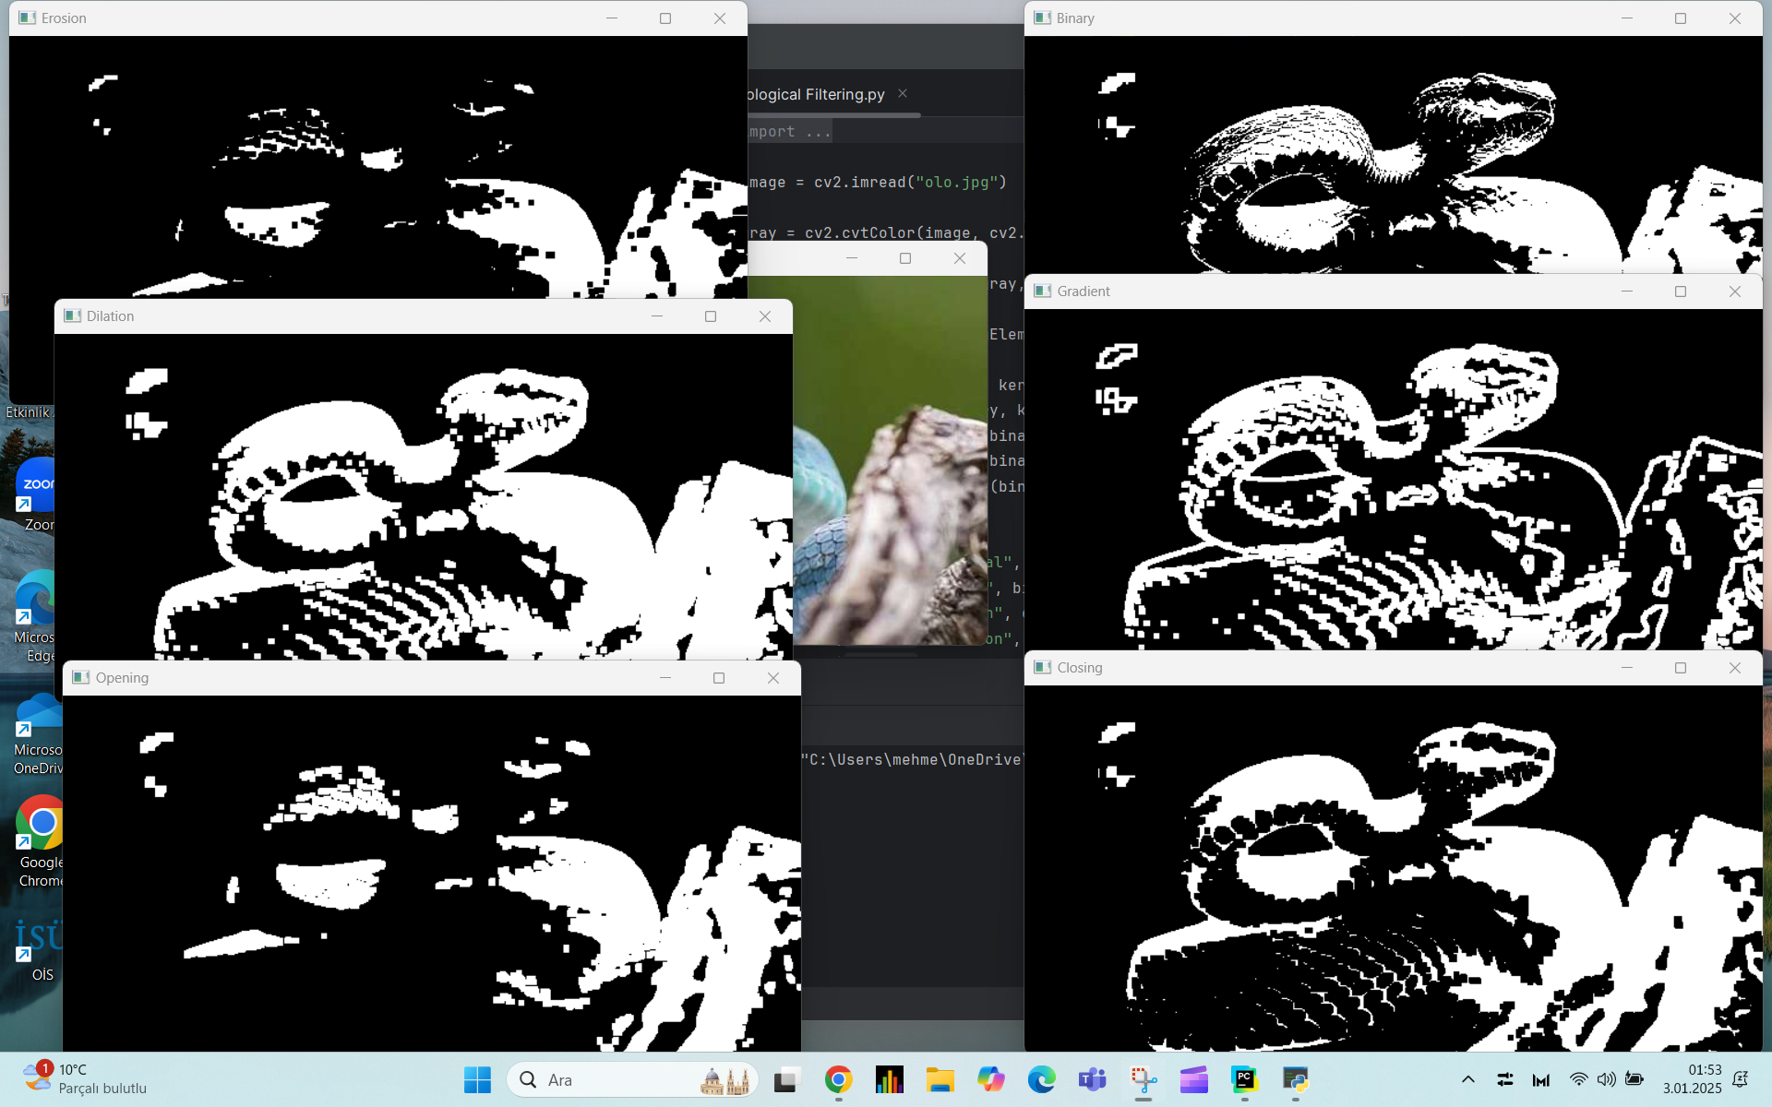
Output:

REPORT
1. Introduction
Morphological filtering is a set of image processing techniques used to process binary or grayscale images, aiming to modify the structure of objects within an image. It is often employed for tasks such as noise removal, edge detection, and shape analysis. In this report, we explore the use of morphological operations such as erosion, dilation, opening, closing, and morphological gradient using OpenCV.
2. Objective
The objective of this task is to demonstrate how to apply different morphological operations on an image (olo.jpg) using OpenCV. These operations allow for enhancing or modifying the shape and boundaries of objects in the image.
3. Morphological Operations Overview
- Erosion:
  - Effect: Shrinks the white regions in a binary image by removing small objects or noise.
  - Use: This operation is useful for separating connected objects or removing small artifacts.
- Dilation:
  - Effect: Expands the white regions in a binary image by filling small holes and joining nearby objects.
  - Use: It is used for connecting objects or filling gaps in the foreground.
- Opening:
  - Effect: The operation consists of an erosion followed by dilation.
  - Use: Opening is typically used for removing small noise while preserving the larger objects in the image.
- Closing:
  - Effect: The operation consists of a dilation followed by erosion.
  - Use: Closing is useful for filling small holes or gaps within the objects.
- Morphological Gradient:
  - Effect: The difference between dilation and erosion.
  - Use: This operation is used for edge detection, highlighting the boundaries of objects.

4. Methodology
- Image Preprocessing:
  - Convert the image to grayscale: This is necessary because morphological operations work on single-channel (grayscale) images.
  - Apply thresholding: The grayscale image is converted to a binary image (black and white) using thresholding, which helps in simplifying the morphological operations.
- Defining the Kernel:
  - A structuring element (kernel) of a fixed size (e.g., 5x5) is used. The kernel is the shape that defines the neighborhood for each pixel during morphological operations.
- Applying Morphological Operations:
  - Erosion: Shrinks the white regions by removing pixels on the object boundaries.
  - Dilation: Expands the white regions by adding pixels to the boundaries of objects.
  - Opening: Removes small noise by eroding and then dilating the image.
  - Closing: Fills small holes within objects by dilating and then eroding the image.
  - Gradient: Highlights the edges of objects by subtracting the result of erosion from dilation.
- Displaying Results:
  - The results of the morphological operations (erosion, dilation, opening, closing, and gradient) are visualized to observe the effect of each operation.
5. Results and Observations
- Erosion: Shrinks the white areas, removing small noise and separating objects that are too close.
- Dilation: Expands the white regions, filling gaps and connecting nearby objects.
- Opening: Removes small white noise while preserving the larger objects.
- Closing: Fills gaps and holes within the objects, creating a smoother appearance.
- Morphological Gradient: Highlights the boundaries of the objects, emphasizing the transition areas between foreground and background.
6. Conclusion
Morphological operations are essential tools for image enhancement and analysis. Using OpenCV, we applied various operations such as erosion, dilation, opening, closing, and gradient to the image. These operations helped in:
- Noise removal
- Object separation or connection
- Filling gaps and holes
- Edge detection
These operations can be tailored for specific tasks in image processing, such as object detection, shape analysis, and noise reduction. By adjusting the size and shape of the kernel, the outcomes of these operations can be optimized to suit different types of images and processing goals.
7. Future Work
Further experiments could involve:
- Applying these operations to different types of images, such as noisy or complex images.
- Experimenting with different kernel shapes (e.g., elliptical or circular) to achieve more targeted results.
- Combining multiple morphological operations to solve more complex image processing tasks like image segmentation or object tracking.

